**Lab 13 – Full Wave Rectifier and Biased Transistor**

**Exercise 1**

**Using PSPICE design a full wave rectifier**

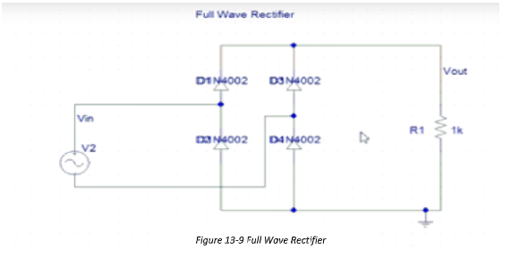

**PSpice Circuit:**

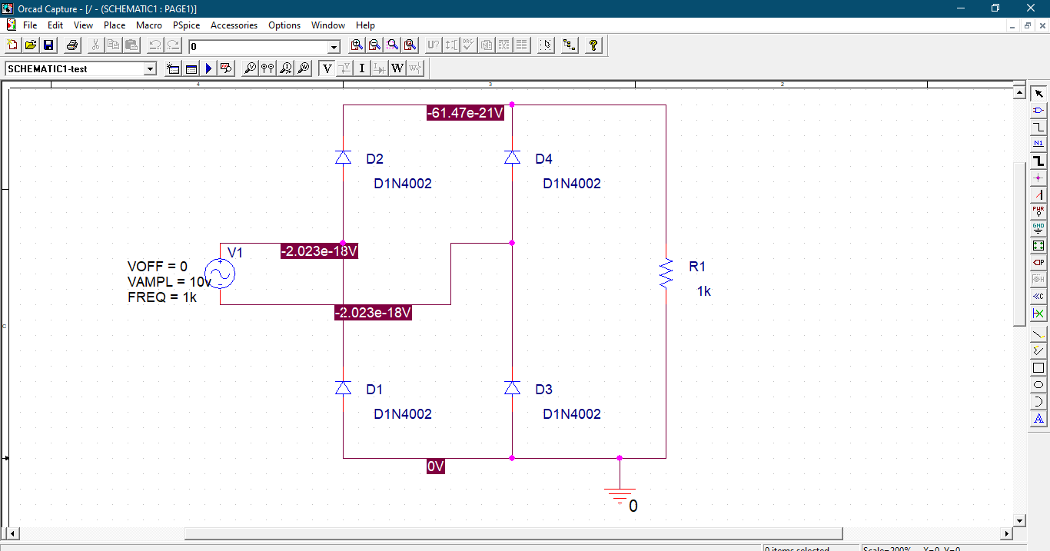

**Simulation Output:**

